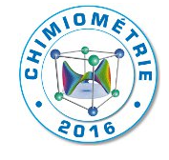

Confirmation – Sponsoring
Chimiometrie 2016 - Namur, Belgium
17 – 20 January 2016

Company name
Contact
Address

Sponsor | Sponsoring | Please indicate your choice
1 | General sponsor
2 | Sponsor Beer and Cheese Welcome
2 | Sponsor gala dinner
2 | Sponsor conference lunch 19 January
2 | Sponsor conference lunch 20 January
3 | Sponsor conference coffee breaks 19 January
3 | Sponsor conference coffee breaks 20 January
4 | Poster prize sponsoring (one sponsor)
4 | Young oral presentation prize sponsoring (one sponsor)

Date Name and signature

Thank you for your support and your successful contribution!

Please send this confirmation to chimio2016@cra.wallonie.be

